Marshalling Policies – No Marshalling Yard
World’s Fair Exhibition Hall

Marshalling Move-In/Out Procedures
We have the systems below in place to help ensure a steady flow of traffic at the Knoxville Convention Center and the World’s Fair Exhibition Hall and that emergency vehicles are able to access the area, if needed. Thank you in advance for your patience, cooperation and understanding. There are only two dock bays at the WFEH so please be patient.

Move-In:
Each vehicle may report to the World’s Fair Exhibition Hall during their designated move-in time or window. No vehicles will be allowed to enter the Venue’s loading dock without first checking-in with the Venue Marshalling Guard at the entrance. They will then be directed to a location to park their vehicle for unloading. Exhibitors may be directed to a specific location to ensure traffic can continue to move through the area.
Please Note: Vehicles may not remain parked at the Venue after unloading. They will need to be moved to the designated parking area or to one of the parking locations around Knoxville.

Move-Out:
Once booth/space is completely packed, an event may require you to pick-up a load-out pass from the Show Office/Manager located at the Venue. After receiving the pass, exhibitors may return to pick-up their vehicles and return to the Venue to load their vehicles during their designated move-out time or window. Booths must be completely packed prior to the exhibitor vehicle being moved to the World’s Fair Exhibition Hall. Like with move-in, exhibitor vehicles will be directed to their parking space by the Venue Marshalling Guard at the entrance or may be directed to a specific location to ensure continued traffic flow through the area.

Thank you and welcome to Knoxville!

World’s Fair Exhibition Hall Team
935 World’s Fair Park Drive
Knoxville, TN 37902

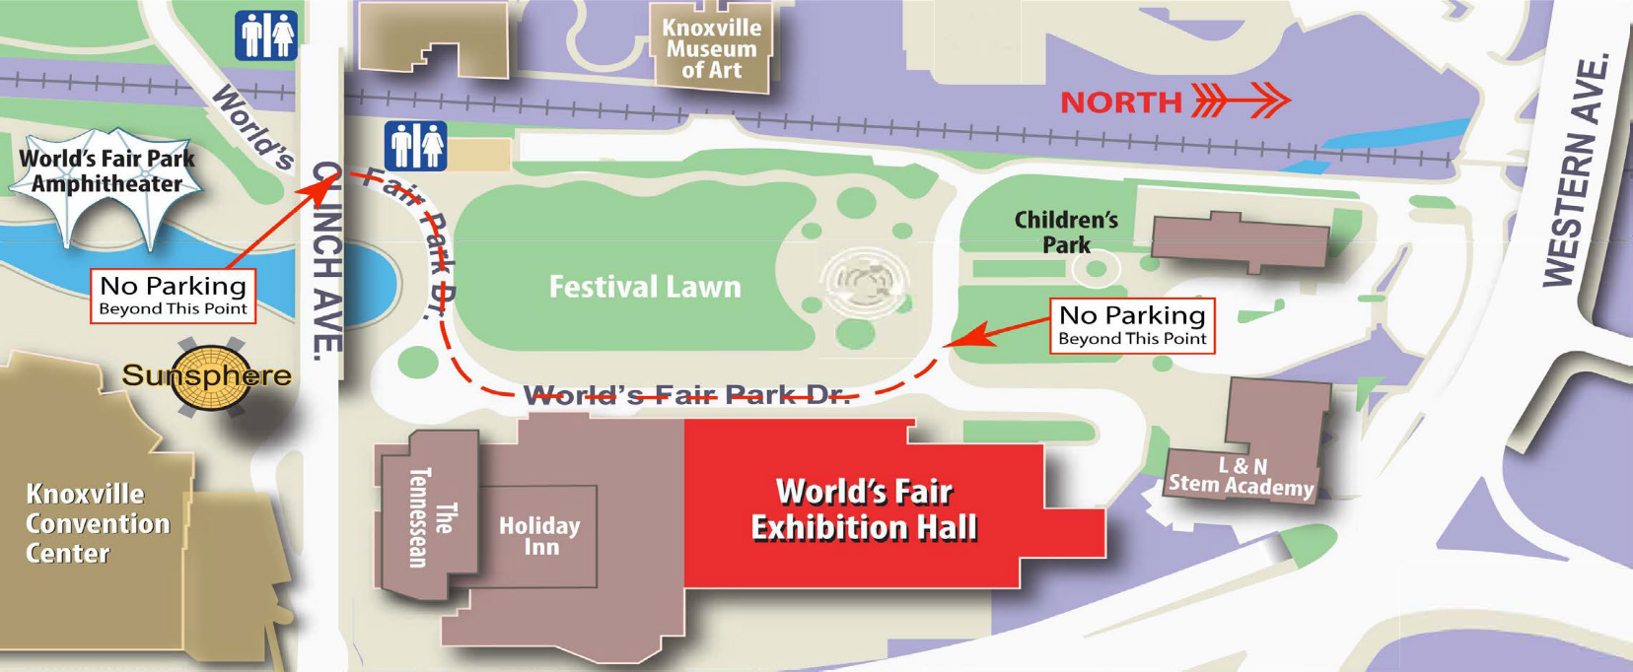
WFEH
Loading Dock

Marriott
DIRECTIONS TO THE WORLD’S FAIR EXHIITION HALL LOADING DOCK
The World’s Fair Exhibition Hall is located at 935 World’s Fair Park Drive Knoxville, TN 37902.
To get to the loading dock, you must turn onto World’s Fair Park Drive. You cannot get to the World’s Fair Exhibition Hall loading dock by turning into the Tennessean or Marriott hotels.

From the North: Take I-75/I-275 to Knoxville. Take the Henley Street (Hwy. 441) Exit. Follow the signs to Henley Street. The World’s Fair Exhibition Hall is on your right on the back of the Holiday Inn after passing through the Henley Street Tunnel. At the first traffic light, turn right onto Clinch Ave. and go across the bridge. Take the first road on the left after the bridge (before the traffic light). This road is World’s Fair Park Drive. Follow World’s Fair Park Drive until you see the Court of Flags. Bear right when the road forks. Follow this road until you get to the loading dock. The loading dock will be between the World’s Fair Exhibition Hall and the L&N Stem Academy.

From the East: Take Interstate 40 to Knoxville and take Exit 388A (James White Parkway/Downtown Knoxville). Take the first exit (Summit Hill), and bear to the right. Stay on Summit Hill Drive until you reach Henley Street. Turn left onto Henley Street then turn right at the next light onto Clinch Ave. and go across the bridge. Take the first road on the left after the bridge (before the traffic light). This road is World’s Fair Park Drive. Follow World’s Fair Park Drive until you see the Court of Flags. Bear right when the road forks. Follow this road until you get to the loading dock. The loading dock will be between the World’s Fair Exhibition Hall and the L&N Stem Academy.

From the South: Take Hwy. 129 (Alcoa Hwy.) into Knoxville. From Hwy.129 take I-40 east to the 388 exit. Take Exit 388 (Highway 441) Henley Street/University of Tennessee. Bear to the left, and after passing through Henley Street Tunnel the World’s Fair Exhibition Hall will be on your right on the back of the Holiday Inn. At the first traffic light, turn right onto Clinch Ave. and go across the bridge. Take the first road on the left after the bridge (before the traffic light). This road is World’s Fair Park Drive. Follow World’s Fair Park Drive until you see the Court of Flags. Bear right when the road forks. Follow this road until you get to the loading dock. The loading dock will be between the World’s Fair Exhibition Hall and the L&N Stem Academy.

From the West: Take I-40/I-75 to Knoxville. Take Exit 388 (Highway 441) Henley Street/University of Tennessee. Bear to the left, and after passing through Henley Street Tunnel the World’s Fair Exhibition Hall will be on your right on the back of the Holiday Inn. At the first traffic light, turn right onto Clinch Ave. and go across the bridge. Take the first road on the left after the bridge (before the traffic light). This road is World’s Fair Park Drive. Follow World’s Fair Park Drive until you see the Court of Flags. Bear right when the road forks. Follow this road until you get to the loading dock. The loading dock will be between the World’s Fair Exhibition Hall and the L&N Stem Academy.

